82nd Craigalmond (Cramond) Scout Group
ANNUAL REPORT 2018/19
The Group continues to thrive with over 200 youngsters on the books, across 2 Beaver Colonies, 2 Cub Packs, Scouts, Sea Scouts and Explorers, with increasing female representation in every section. These sections are supported by over 30 talented, enthusiastic and committed leaders and helpers, who weekly give generously of their time as well as through training and at camps.
Monday Beavers this year have had lots of fun. With two new leaders and brilliant young leaders, lots of fun has been had learning new skills and plenty of games.
We have focused on badges to help those nearing the end of Beavers achieve their bronze award, successfully awarding 2 recently, with a few more very soon. We've looked at teamwork through space badges, animal care with Pets at Home (Beavers holding the snakes but none of the leaders!), learnt about each other and other Beavers internationally, climbed at Ratho, learning compass and map skills and then tested them at our very successful Beaver and Cub camp. Very proud of the Beavers who showed great spirit and helped each other on the ‘blind trail’, in the lashing rain, all while still with big smiles.

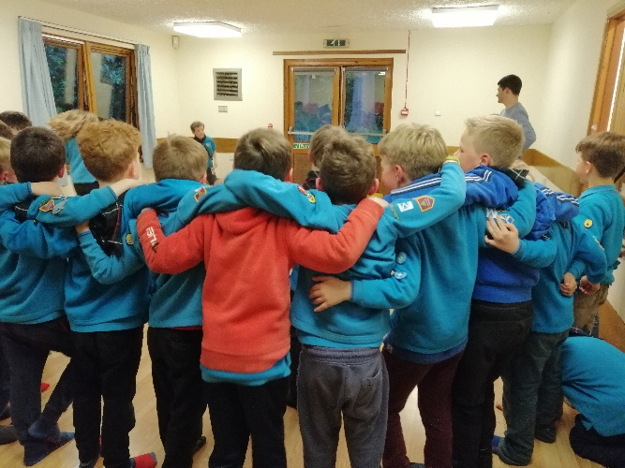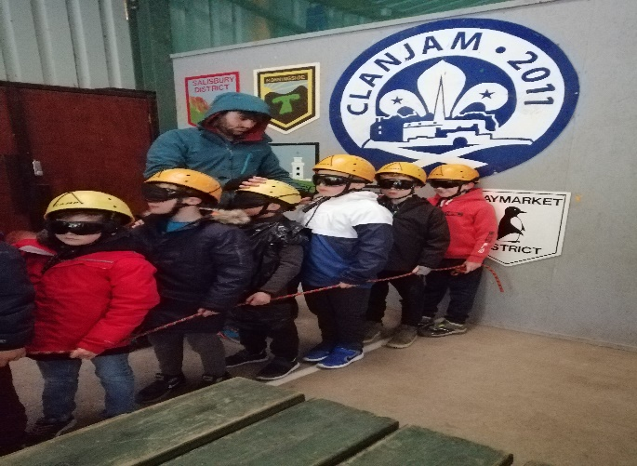

Friday Beavers have had an action-packed year. Our Beavers have been learning about Emergency Aid and what to do in an emergency situation and they also learned about the Green Cross Code. Continuing the subject of safety, they've also learned about fire safety, how to light a candle and how to be safe around a campfire, all of which helped us enjoy a fabulous Guy Fawkes evening with campfire songs, hot dogs and hot chocolate. We've been learning outdoors skills including pioneering, tents and knots, the importance of clear drinking water and how and when to use a water filter. The Beavers have developed a respect for the world around them by learning about endangered animals and about why and what we should recycle, and we had a fun evening of creating models out of junk. In the summer term so far, we've been out and about. Many of our Beavers attended the Beaver Sleepover at Bonaly. They got to take part in lots of adventurous activities and played lots of games, completed a ‘blind trail’ in the rain and enjoyed a really tasty 75th Anniversary cake, baked by Sarah – thank you! The highlight of the year so far seems to have been the sausage sizzle on the beach at Dalmeny which was enabled by our Sea Scouts friends ferrying the whole section from the Cramond boat club over to the Beach where we had a campfire that we used to warm up our sausages. It was a fantastic evening.

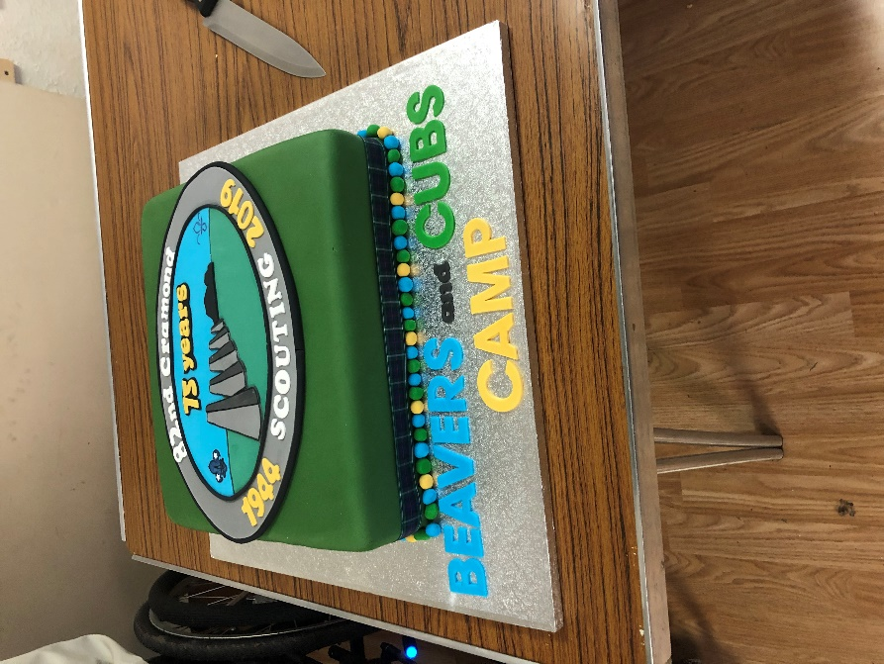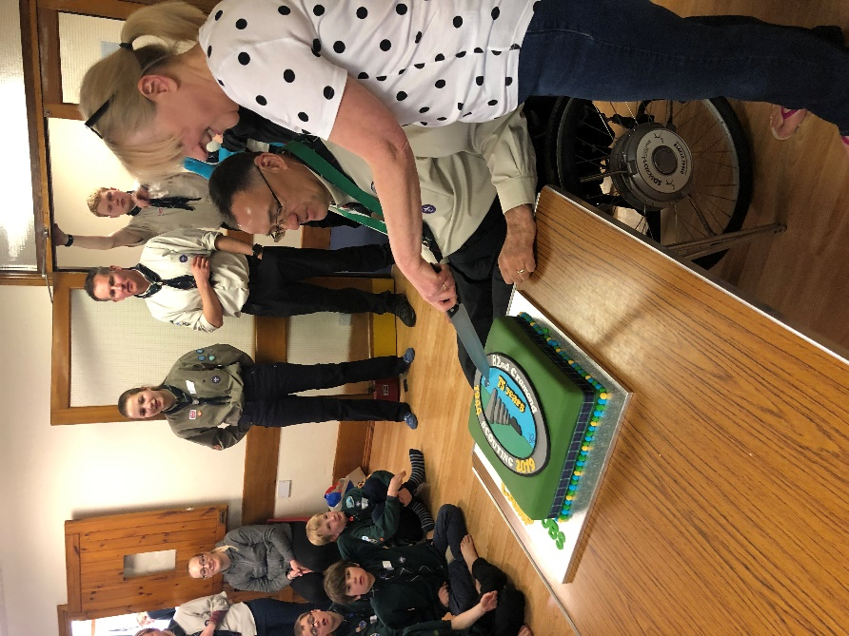

Monday Cubs have been hard at work earning their Challenge Badges including supporting the Cramond Heritage Association cleaning the local signs, plus a great night away on camp at Bonaly. We managed two great camps this year, the first last September at Fordell, followed by an excellent joint camp with Friday Cubs an both Beaver colonies to Bonally.

The summer term is packed full of our favourite meetings including football training in advance of the District Cubs Football Tournament and our annual Bike & Chips night. We have been very lucky to have a consistent leadership team and grateful to our weekly parent volunteers. After the summer break we look forward to 10 Beavers swimming up.

Friday Cubs goes from strength to strength, with 36 Cubs now attending on a Friday night. The Cubs have enjoyed completing their Science badge by taking part in experiments and making bristle bots. They have been working on their Personal Challenge badge at home, which contributes to their Silver Award and we also held a bring your own badge night, where the Cubs could complete activity badges at home and then show everyone what they had achieved in the meeting. We have also focussed on life skills, with many of the Cubs achieving home help, road safety and personal safety badges. We recently held a highly successful one-night camp at Bonaly with the Beaver packs and are looking forward to a 2-night camp at Fordell in September. A very successful year, with over 250 badges and 8 Silver Awards gained during the year.

Scouts It’s been a very successful year for our 70 or so Scouts with some great highlights including an excellent camp programme with Scout camps at Culzean (Summer), Douglaswood, Dundee (Easter) as well as our annual overnight camp and beach tidy at Dalmeny Estate.

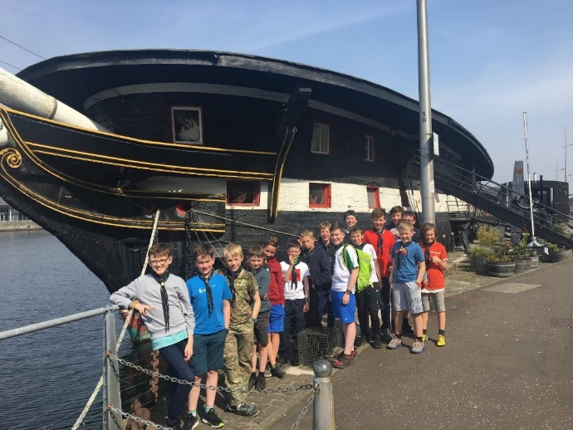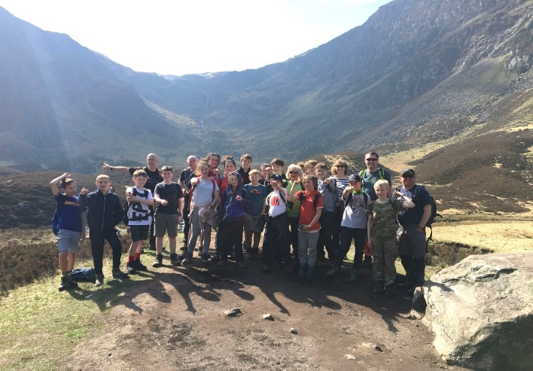

We also had a varied Friday evening programme, all designed to facilitate “skills for life”, including a disability and inclusion night, problem solving and creative challenges, backwoods cooking, and lots of wide games. We also celebrated Burns Night and Guy Fawkes Night and did a beach clean at Dalmeny. We had a number of offsites, including Adventure golf, swimming and diving, trampolining and a Parkour session as well as cycling to Dalmeny. We also supported the Kirk Youth Service where we focused on the WWI anniversary, which our Scouts really got engaged in.

We did a range of fundraising including the Santa Sleigh in December, Plant Sale in May, with the Duck Race planned for June. The culmination of all of this is that in 2018 we awarded the Chief Scout Gold Award to 7 Scouts.

Sea Scouts continues to thrive and is greatly in demand with the Sea Scouts having enjoyed many sessions of Sailing, Kayaking, Windsurfing and Power Boating. It is pleasing to see the progression in skill levels and confidence, which culminated at the Scottish Sea Scout Regatta. Cramond Sea Scouts took a clean sweep of sailing trophies, and with our Explorers finishing as overall winners. The annual trip to the National Sport Centre at Cumbrae is always the highpoint of the Sea Scouts year as the facilities and staff always deliver a fabulous weekend of water sports.

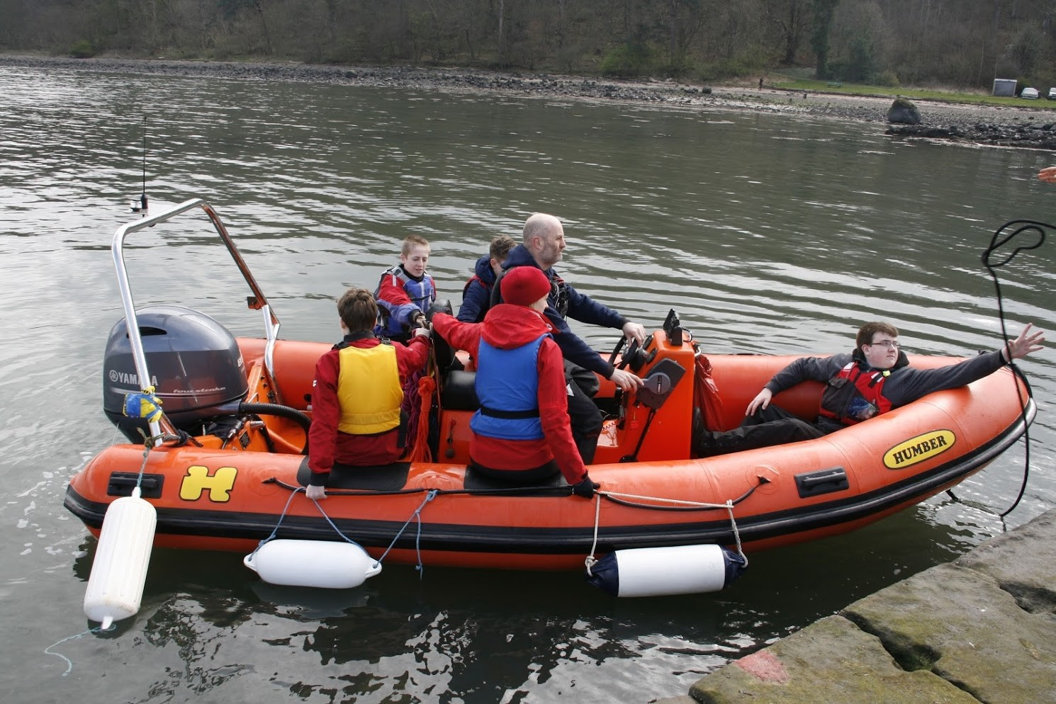

Explorers. Summer camps book-ended the Scouting calendar, 2018 saw the Explorers head to the idyllic Craggan campsite near Crieff. A theme of Indiana Jones loosely tied the activities together. From wide games, where explorers had to search to find the holy grail, to building model (V2) rockets. The older Explorers also set off on a major overnight hike taking in two Munros, Stuc a’ Chroin and Ben Vorlich, camping high on the slopes of Stuc a’ Chroin at 2,400 feet- quite probably the highest accommodation in the UK that night. Other shorter trips include a one-night wild camp in the Pentlands and the ‘Woolly Jumper’, an Explorer and Guide senior section camp with 350 young people in Aberdeen. The Santa’s Sleigh is the Explorer’s big fund raising event of the year. Four nights around the local area, with an extra night this year supporting the Barnton light switch on. Again, the Explorers chose to support the RNLI and Northwest Foodbank with the money and food collected. This year ‘The Yard’ also joined the good causes that we were able to raise money for. As always, thanks to everyone who helps to make this such a success each year. Thanks also to all those who have been supporting the DoE Award and Young Lleader programmes; this has allowed us to recognise many more of our Explorers in achieving the highest awards in Scouting. As a result, even more Explorers are advancing from the Scout Platinum Award to the Scout Diamond Award. The Young Leader programme has also been working well with the Explorers providing valuable support to the younger scout sections. This programme has seen the award of the first Young Leader Belt in many years, a significant achievement and commitment which requires completion of all 11 training modules and 4 missions. This year will close and start with another Summer camp, this time we will be heading up to Spean Bridge near Fort William, paving the way for another year of adventure”
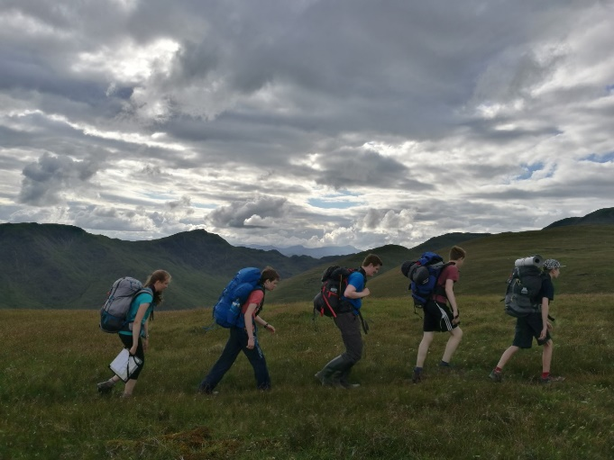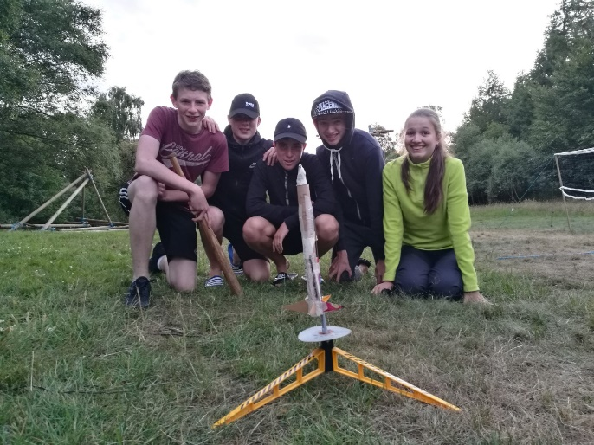
“Anyone see the camp-site?” 3, 2, 1…!

